3. System Architecture Document

3.1 Overall Architecture
The system follows a layered architecture consisting of a presentation layer (frontend), an application/business logic layer (FastAPI backend), and a data layer (PostgreSQL and Redis). External integrations (ORCID, DOI/CrossRef, file storage, email/notification services) connect to the backend through dedicated service modules.
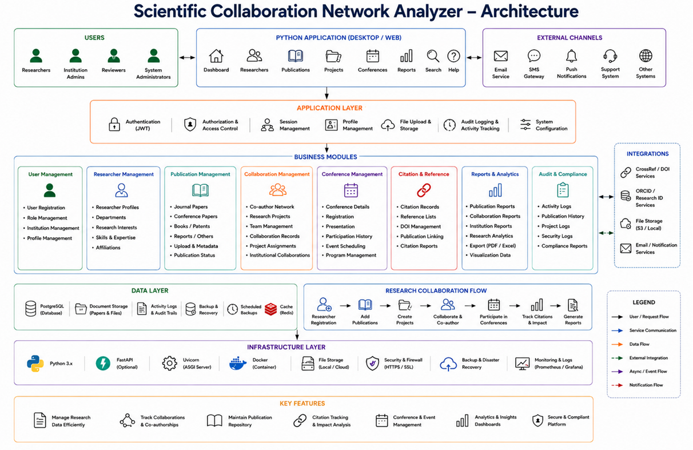

3.2 Frontend
The frontend is implemented using HTML, CSS, and JavaScript, organized into pages corresponding to each module (dashboard, researchers, publications, projects, conferences, reports). The frontend communicates with the backend exclusively through RESTful API calls and renders JSON responses into the user interface.

3.3 Backend
The backend is implemented using FastAPI and organized into routers, services, models, and schemas. Routers handle HTTP request routing, services contain business logic, models define the ORM structure via SQLAlchemy, and schemas define request/response validation via Pydantic. Uvicorn serves the application, and Alembic manages database migrations.

3.4 Database
PostgreSQL serves as the primary relational data store for all persistent entities (users, researchers, publications, institutions, conferences, projects, citations, collaborations). Redis is used as a caching layer to reduce database load for frequently accessed, read-heavy data such as dashboard statistics.

3.5 API Communication
All communication between the frontend and backend occurs over HTTPS using RESTful JSON APIs. Each request to a protected endpoint must include a valid JWT bearer token in the Authorization header. Responses follow a consistent JSON structure with status, data, and error fields.

3.6 Authentication Flow
Authentication uses JWT tokens issued upon successful login. Refer to Section 8 (Authentication Flow Document) for the complete flow diagram and description.

